Analysis of Social Media Contents

The data gathered from a company's profiles on various social media platforms, including Facebook, Instagram, Twitter, LinkedIn, YouTube, and Snapchat, is known as social media data.

The likes, shares, comments, responses, clicks, and other interactions it generates help us better understand how people consume and interact with content. We can enhance our marketing initiatives, stay current with developing trends, and provide our clients with proof of your outcomes by gathering and analyzing social media data. Additionally, it can assist us in continually enhancing and improving your plan. We spend less time speculating and pose a lower risk of error when data inform us.

# Data Collection

The process of extracting data from a webpage is known as web scraping. This data is gathered and then exported in a way that the user will find more valuable. A spreadsheet or an API, for example. Although web scraping can be done manually, automated methods are typically preferred since they can be less expensive and perform more quickly. Web scraping, however, is typically a challenging operation. Web scrapers differ in functionality and features since websites come in a wide variety of designs and sizes.

A web scraping technology that automatically collects data from social media networks is referred to as a "social media scraper" in many cases. They also include blogs, wikis, news websites, and social networking sites like Facebook, Twitter, Instagram, LinkedIn, and so on. These portals all have one thing in common: they produce user-generated content in the form of unstructured data that can only be accessed online.

Unquestionably, the largest and most dynamic dataset regarding human behavior is data that has been scraped from social media. It offers social scientists and business professionals completely new options to comprehend people, communities, and society as well as to discover the enormous treasure concealed in the data. The early commercial adopters of social media data analysis were typical companies in the retail and finance sectors. These companies used social media analytics to harness brand awareness, customer service improvement, marketing strategies, and even fraud detection. Social media analytics: a survey of techniques, tools, and platforms.

In addition to the uses listed above, the current social media dataset can be used for:

* Customer sentiment measurement
* Target market segmentation
* Online branding monitoring
* Market trends identifying

Top Social Media Scrapers for gathering Text, Images, and Video data:

1. Octoparse.
2. Dexi.io
3. OutWit Hub
4. Zyte
5. Parsehub
6. Scraper API
7. Bright Data
8. Apify
9. Proxycrawl
10. ScrapingBee
11. Autoscraper
12. Scrapy
13. Selenium
14. Beautifulsoup

# Data Preprocessing

We must save massive amounts of scraped data in an appropriate format. We may choose to save the data in a text file, an image file, a video file, or more formally in a CSV file, an excel sheet, or by storing photos in various directories. Otherwise, we might prefer to immediately save information in a database. Understanding how to store scraped data in a file or database is therefore essential. It's important to have a clear idea of the data's appearance before we scrape or save it. It would probably be wiser to store more organized data that is consistent in a CSV or excel file. Contrarily, it would be simpler to keep data that is randomly scraped from several web pages in distinct files. Textual material is frequently garbled and includes several symbols, emoticons, and invisible characters. We preprocess them as a result by eliminating stop words, non-ASCII characters, numerals, URLs, and hashtag symbols. Additionally, we swap out every punctuation for white space. On the image side, we perform the usual preparation operations, which include scaling an image's pixels between 0 and 1 and then normalizing each channel in relation to the dataset for the deep learning algorithm.

# Building Multimodal Algorithm for Text and Image data

**Text Modality:** We employ the Convolutional Neural Network (CNN) for text modality due to its superior performance in tasks requiring the segmentation of social media information connected to crises. We specifically build a CNN with preferred hidden layers. We used a pre-trained word2vec model to extract the words from the tweets and then zero-padded them for equal length before turning them into a word-level matrix to feed into the network. On a sizable text dataset, the word2vec model is trained using the Continuous Bag-of-Words (CBOW) method.

To create a higher-level fixed-size feature representation for each text vector, the input is then passed through a series of consecutive layers, starting with the convolutional layer and ending with the max-pooling layer. Then, one or more fully linked hidden layers are passed over these fixed-size feature vectors, followed by an output layer. Rectified linear units (ReLU) are used as the activation function in the convolutional and fully-connected layers, and the softmax activation function is used in the output layer. The Adam optimizer is used to train the CNN models. When optimizing for the classification loss on the development set, the learning rate is set at 0:01. To prevent overfitting, a dropout rate of 0:02 and a maximum of 50 epochs are utilized. Based on the precision of the development set and the patience of 10, we established early-stopping criteria. With equivalent window sizes of 2, 3, and 4, we employ 100, 150, and 200 filters, respectively. The pooling length and filter window size are the same. We also use

batch normalization.

**Image Modality:** We use a transfer learning strategy for the image modality since it works well for visual recognition tasks. Using the weights from a model that has already been trained is the notion behind the transfer learning approach. To initialize our model, we use the weights of a VGG16 model that has already been trained on ImageNet. We modify the network's final layer, the softmax layer, in accordance with the specific instead of the original 1,000-way classification assignment at hand. With the help of the transfer learning method, we can move the network's features and parameters from a general domain—large-scale picture classification—to a more focused one, in this instance informativeness and humanitarian categorization tasks. With an initial learning rate of 106, we train the picture models using the Adam optimizer. After 100 iterations, accuracy on the development set stops getting better, at which point the learning rate is dropped by a factor of 0:1. We made the particular epochs maximum with an early-stopping condition.

**Multimodal: Text and Image:** We outline the multimodal deep neural network architecture that we'll be using in the experiment. The VGG16 network is what we utilize for the imaging modality, as seen in the figure. We employ a CNN-based architecture for textual data. We have another hidden layer of size 1,000 from each side before creating the shared representations from both modalities. To ensure that both modalities contribute equally, the same size should be chosen. There is no particular justification for selecting the size of 1,000 in the current experimental setup; nevertheless, this size can be improved empirically. There is a hidden layer following the concatenation of both modalities before the softmax layer. For training the model, we employ the Adam optimizer with a 32-piece minibatch size. Early-stopping condition is used to prevent overfitting, and ReLU is selected as the activation function. No hyper-parameters are tuned for this experiment (e.g., the size of hidden layers, filter size, dropout rate, etc.). Therefore, there is a possibility for advancement in subsequent research.

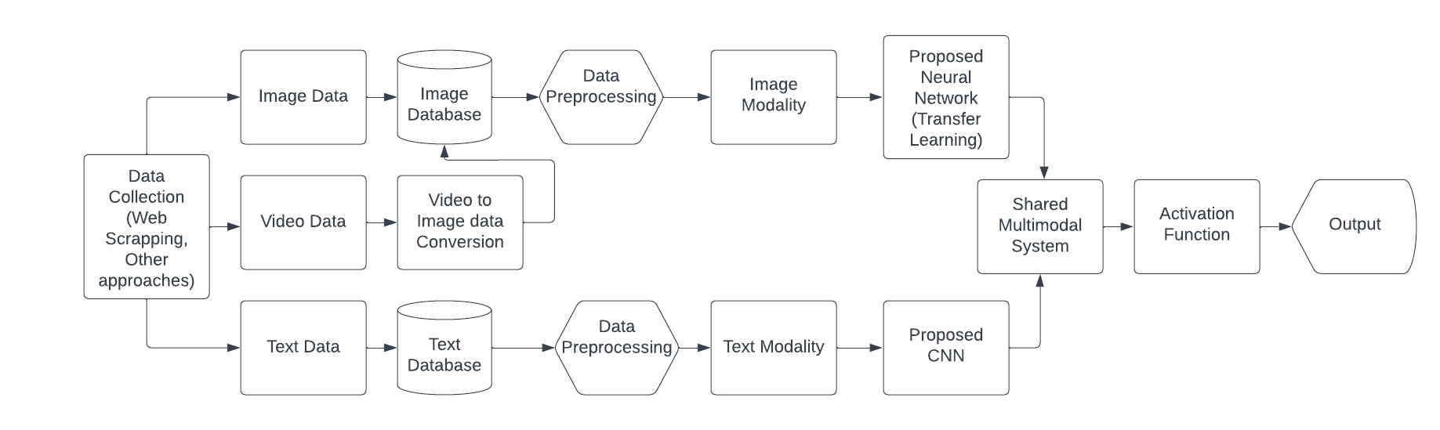

Fig. The multimodal architecture uses both text and visual input for the segmentation problem.

# Deployment

We must first create your model before we can deploy a machine learning application. Only a minority of the ML models produced by ML teams for a given project really make it to the deployment stage. Typically, these models are developed in an offline training environment, either through a supervised or unsupervised procedure, where they are fed training data. Checking that the code is of a high enough standard to be deployed comes after a model has been constructed. If not, it must be cleaned and optimized before being retested. And where necessary, this should be repeated. By doing this, you can guarantee that the ML model will work in a real-world setting and provide other team members the chance to learn how the model was created. This is crucial since ML teams don't operate in a vacuum; as part of the development process, other people will need to review, examine, and streamline the code. As a result, a crucial step in the process is providing a thorough explanation of the model's development and any results. Before deploying their models, ML teams should place their models into a container as containerization is a key tool for ML deployment. Containers are the ideal setting for deployment since they are predictable, repeatable, immutable, and simple to coordinate. Because they make scaling and deployment simpler, containers have grown to be very popular for the deployment of ML models over time. Additionally, containerized ML models are simple to update and modify, lowering the possibility of downtime and simplifying model maintenance.

# Monitoring and Maintenance

Successful ML model deployment depends on continual governance, maintenance, and monitoring. Continuous monitoring helps to confirm that the model will be effective over the long run; initial testing in a live environment is not sufficient. Beyond creating ML models, it's critical for ML teams to set up procedures for efficient monitoring and optimization so that models may be maintained in the best possible shape. It is possible to identify and correct problems like data drift, inefficiencies, and bias after continuous monitoring systems have been developed and put into place. To prevent the model from straying too far from the live data, it might also be possible, depending on the ML model, to routinely retrain it with fresh data. A single, modest model's deployment and testing can be handled manually. However, you should automate for bigger or more models at once. This will make it easier for you to handle individual parts, guarantee that ML models will be automatically trained with consistently high-quality data, conduct automatic testing (for instance, of data quality and model performance), and scale models automatically in response to the environment. A successful deployment process depends on ongoing evaluation and development. This is because constant monitoring allows you to identify possible problems like model drift and training-serving bias before they cause harm. ML models deteriorate with time.